**2.4 USE CASE DIAGRAM**

Since our project is a client server based application so it can run on multiple machines and can serve for different kind of users at a single point of time. The user could be teacher, student or an administrator who can collectively participate in the system to perform tasks of mutual interest. The following diagram gives a pictorial view of mutual relation between users themselves and also between users and the system.

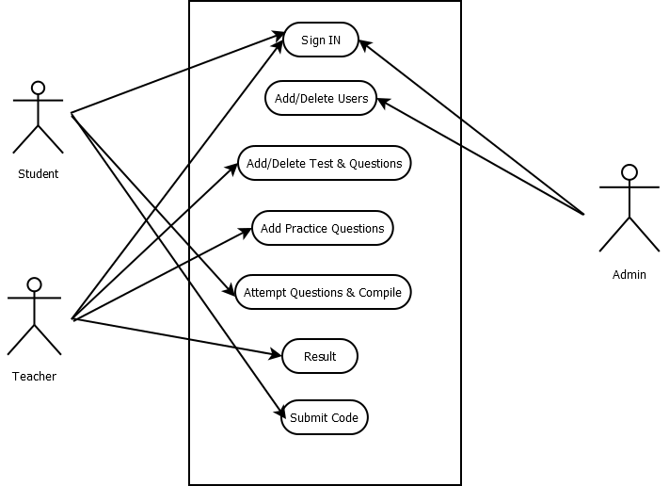

Fig. 2.1: Use Case Diagram